**Project Design Phase-I**

**Data Flow Diagram & User Stories**

|  |  |
| --- | --- |
| **Date** | **26-05-2025** |
| **Team-ID** | **PNT2025TMID09488** |
| **Project Name** | **Groceries Site Using Mern Stack** |
| **Maximum Marks** | **4 Marks** |

**Data Flow Diagrams:**

A **Data Flow Diagram (DFD)** illustrates how data moves within the Freelance Finder platform. It captures how users (freelancers and clients) interact with the system, how information flows between different components, and where the data is stored.

Rectangle 17, Textbox

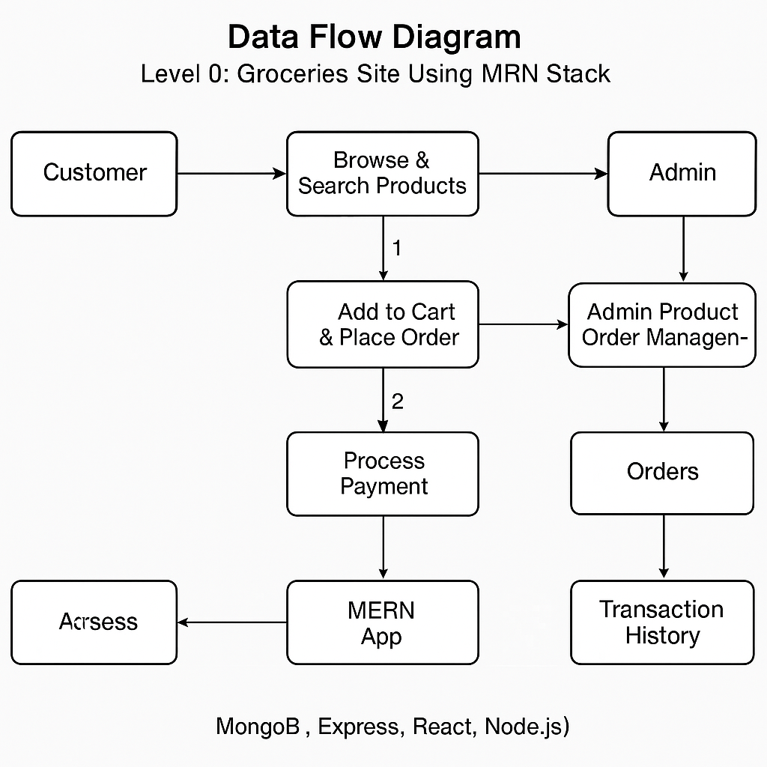

**User Stories**

**User Story Table**

|  |  |  |  |  |  |
| --- | --- | --- | --- | --- | --- |
| **User Type** | **Functional Requirement(Epic)** | **User Story/Task** | **Acceptance Criteria** | **Priority** | **Release** |
| **Customer** | Product Browsing | As a customer, I can browse and search for grocery items. | Search returns relevant items; categories are shown properly. | **High** | Sprint-1 |
| **Customer** | Cart & Checkout | As a customer, I can add items to my cart and proceed to checkout. | Cart updates correctly; order summary is shown during checkout. | **High** | Sprint-1 |
| **Customer** | Order Tracking | As a customer, I can track my placed order in real-time. | Order status updates are visible in the user dashboard. | **Medium** | Sprint-2 |
| **Admin** | Inventory Management | As an admin, I can add, update, and delete grocery items. | Changes reflect instantly on the product listing page. | **High** | Sprint-1 |
| **Admin** | Order Management | As an admin, I can view and manage all orders. | Orders can be updated and assigned for delivery. | **High** | Sprint-2 |
| **Delivery Staff** | Delivery Dashboard | As a delivery staff, I can view the orders assigned to me for delivery. | Delivery information is clearly displayed and can be marked done. | **Medium** | Sprint-2 |
| **Customer** | Payment Integration | As a customer, I can securely pay for my groceries online. | Payments are processed securely and shown in history. | **High** | Sprint-2 |
| **Customer** | Review System | As a customer, I can leave a review for products after purchase. | Reviews are visible on the product page. | **Medium** | Sprint-2 |
| **Admin** | User Moderation | As an admin, I can manage users and block/report suspicious activity. | Reports are logged and actions can be taken. | **Medium** | Sprint-2 |